The Man from Thetford

This essay assumes some knowledge of the life and work of Thomas Paine. For the benefit of those who still have ahead of them the pleasure of reading a biography of Paine, I have added, as a kind of aperitif, a brief summary of the main events of his life story.
Thomas Paine was born on January 29, 1737 in Thetford. His mother was a lawyer’s daughter, and his father, a Quaker, was a staymaker. He was educated at Thetford Grammar school until the age of 12, when he was apprenticed to his father. In the summer of 1756 he fled Thetford for London and signed up to sail on a privateer. The auguries were not good: the ship was called the Terrible, its captain was William Death, one of the lieutenants was called Devil and its surgeon was a Mr Ghost. The youthful Paine was not deterred, but he was prevented from going to sea “by the affectionate and moral remonstrance of a good father,” as he later put it. He had a lucky escape, because the Terrible was captured by a French privateer, and most of its crew were killed. Paine worked in London as a staymaker, and for a short period he did sail aboard another privateer. In 1759 he married, but the following year his wife died in childbirth. By 1764 he was working on the North Sea coast as an excise man. Four years later, still working for the Excise, he moved to Lewes, where he became a prominent member of the Headstrong Club, a political debating society that met in a pub. In 1771 he married again, and in the process became the joint proprietor of a tobacconist shop. In 1772 he took up the cause of his fellow excise men by lobbying Parliament on their behalf for an improvement in their terrible wages. He was rewarded by being dismissed from his own job. Meanwhile, his second marriage was failing, together with the marital business, and in 1774 he separated from his wife as honourably as he could, settled up in Lewes and departed once again for London. Here he met Benjamin Franklin, who gave him a letter of introduction and advised him to sail for America, which he did in September 1774.
Paine settled in Philadelphia, where he edited and wrote for the Pennsylvania Magazine. His first publication was an essay advocating the abolition of slavery, a cause he continued to pursue. In early 1776 he published his pamphlet Common Sense, which sold immediately in huge quantities. He made a powerful appeal for independence from England and the organization of a federal government. When the War of Independence began he served as a soldier, and also wrote The American Crisis, a series of highly influential propaganda pamphlets. He became the secretary to the committee of foreign affairs of the Continental Congress in 1777, but later resigned to become clerk of the Pennsylvania Assembly.
After the war Paine returned to Europe, where he pursued his interest in bridge-building. In answer to Edmund Burke’s Reflections on the French Revolution (1790), he wrote Rights of Man (1791-2), a strong defence of republican government, which also outlined a proposal for national social insurance. The book was suppressed, but not before it had found a huge readership. In 1792 Paine was tried and convicted, in his absence, for seditious libel. Meanwhile, he had fled to France where he was elected to the French National Convention. When the Girondists fell from power in 1793 Paine was excluded from the Convention, then arrested and imprisoned in the Luxembourg Palace, where he became ill and nearly died. He only escaped execution by chance.
Once released he wrote The Age of Reason (1794-6), in which he attacked the principle of biblical revelation and denounced Christianity. The book lost him many friends and supporters in Europe and the US. Among his old political friends, only Thomas Jefferson stood by him, though his patience ran out in the end. Paine returned to the US in 1802, where he spent the rest of his life, subsisting in squalor on a small government pension. In his final years he was dogged with unpopularity, alcohol and ill health. While on his deathbed he was visited by several people who hoped to elicit a recantation of his disbelief in Christianity. They went away disappointed. He died on 8 June 1809. Only six mourners came to his funeral, two of whom were black, most likely freedmen. In 1819 William Cobbett had his bones dug up from their grave in New Rochelle, New York State and brought them back to England with the intention of raising a monument to Paine. The monument was never built and after Cobbett’s death, in 1835, the bones were lost.
Some words from Bertrand Russell’s essay on Paine could well serve as an epitaph: “…to all champions of the oppressed he set an example of courage, humanity, and single-mindedness.”

During the course of this essay I have drawn on many sources of biographical information. Among them I would recommend John Keane’s Tom Paine, A Political Life (1995), which is exhaustive and authoritative. To someone who wants a shorter introduction I would suggest Bertrand Russell’s essay, “The Fate of Thomas Paine (1934). Christopher Hitchens has written a study of Rights of Man (2006), which also provides a typically illuminating account of Paine’s life and character.
There is no substitute for reading the man himself. The qualities that turned Paine’s pamphlets into best-sellers in their day have not been extinguished by time.
A good selection of his works is to be found in Thomas Paine: Rights of Man, Common Sense and Other Political Writings, edited by Mark Philp and published in Oxford World’s Classics (1995).

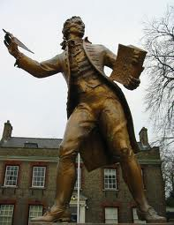

Several interesting statues are to be found in Thetford, but the one that occupies the most prominent position in the town depicts Thomas Paine. It stands in King Street outside King’s House, occupying a semi-circular recess set back from the pavement and lined with stone benches. Not everyone would agree that its subject, Thomas Paine, deserves this honour, or deserves a statue at all. On the other hand, those who find him objectionable can have the satisfaction of knowing that most people – or so I would guess – who walk past his bronzed effigy have no idea who Thomas Paine was or why he deserves a statue.
In this essay I want to argue that Thetford should embrace Paine as a hero, for he was a truly heroic man and Thetford should be proud of its connection with him. But first I want to investigate the statue itself, which – to my eye at least – possesses some curious and unhelpful features, which may have added to the continuing obscurity surrounding Paine and his achievements.
*
The statue of Thomas Paine, sculpted in 1964 by Sir Charles Wheeler, is an imposing work. Standing 7½ feet high, it is further elevated by its pedestal of Portland stone, which adds nearly another six feet, causing the figure to tower over the pedestrian, who must crick his or her neck to look up at the Paine’s face. This forceful impact is compounded by the “vigorous if contorted” stance chosen by the sculptor for his subject.
Paine is depicted in the costume of his day: silk cravat, long waistcoat, frock coat, breeches, stockings, buckled shoes, and he is wearing a plain wig with a ribbon at the back. He holds a quill pen in one hand and a book in the other. Carved into the top edge of the pedestal is the caption “1737 THOMAS PAINE 1809”. The pedestal is stained with blue-green streaks, presumably caused by rain carrying oxides from the bronze to the stone, and the result does not make the lettering easy to read. The front panel of the pedestal depicts a globe carved in bas relief and supported by a pair of wings. Two ribbons float across the globe, bearing the text: MY COUNTRY IS THE WORLD / MY RELIGION IS TO DO GOOD.
The two panels facing west and east are densely packed with text, making the statue as much an object to read as look at, but the weary shopper, pausing for a rest on one of the stone benches, would be hard pressed to make sense of them. Easiest to read, though perplexing, is the ringing announcement at the foot of the rear panel: WORLD CITIZEN / ENGLISHMAN BY BIRTH, FRENCH CITIZEN BY DECREE / AMERICAN BY ADOPTION. But nowhere amongst these prolix inscriptions is there anything to enlighten the enquiring pedestrian or skateboarder as to the identity of this Thomas Paine. If he was a writer, as his quill seems to suggest, what did he write? Most extraordinary of all, none of the inscriptions mention the fact that Thomas Paine was born in Thetford.
When the statue was unveiled its sculptor, Sir Charles Wheeler, made a speech in which he said that there were two problems to be faced in attempting a sculpture of an historical figure. One was achieving a physical likeness, and in this case he had mainly relied on engravings of a portrait by George Romney. The other problem was capturing the spirit of the subject, and here he had depended on reading Paine’s work.
What did Paine look like? And has Wheeler created an authentic likeness?
George Romney painted Paine’s portrait in June 1792, a date which in itself made the picture a remarkable event. At that time Romney was not only at the height of his powers, but he was the most fashionable portrait painter of his day. His subjects had included dukes and earls, admirals, M.P.s, archbishops and bishops, and judges as well as many society women. He had painted William Pitt, then the prime minister, more than once. Indeed, so distinguished was his career that one wonders what persuaded him to paint a man as dangerous as Paine – dangerous to his reputation, that is. For at that moment Paine was probably the most abominable man in Britain in the eyes of the establishment, the class to which Romney looked for patronage.
A few months earlier, on February 16, 1792, the second part of Paine’s Rights of Man was published. Sales were enormous, which meant that its circulation was still greater. John Keane estimates that 200,000 copies were sold in England, Wales and Scotland within a year of its publication, though the figure is probably even greater if abridged versions and editions combining Parts One and Two are taken into account. The people buying and reading this explosive, six-penny pamphlet, belonged to the working class, the very citizens whose rights, according to Paine, were being abused and ignored by government. In France, where Louis XVl had already been declared a constitutional monarch, the Revolution was causing the British ruling powers extreme anxiety, but they were still more concerned about growing agitation at home for the increase of democracy. Paine was seen as the chief agitator, and the government set about suppressing both the book and its author.
Despite the enormous popularity of Rights of Man, many demonstrations of support for king and country broke out, some of them spontaneous, others encouraged by magistrates, squires and members of the clergy. In a Suffolk village, for example, a wealthy rector offered two guineas as a reward for burning Paine’s effigy. In towns all over the country effigies of Paine were hanged, whipped and burnt. In the ugly atmosphere of public violence and official hostility that developed, Paine’s personal safety was under constant threat. In early May the government issued a proclamation against seditious writing and magistrates were ordered to search out the authors and printers of such material. Booksellers that stocked Paine’s book were harassed and in some cases prosecuted, fined and even imprisoned. On May 21 Paine was summonsed to appear in court in just over two weeks time to face charges of seditious libel, a very serious crime. But then the government postponed the trial until December, probably as a strategy to frighten him into emigrating.
Paine’s reaction was characteristically defiant. He brazenly encouraged his fellow citizens to support the revolution in France, and he announced to the press that he was ‘very quietly sitting to MR. ROMNEY, the painter.’ The sittings were arranged by Paine’s friend Clio Rickman. When the portrait was finished Rickman declared in a burst of hyperbole that he considered it “perhaps the greatest likeness ever taken by any painter”. (Did Rickman also pay the painter’s fee?) Romney must have worked fast because by September 13, 1792 Paine had been forced to flee the country, never to return.
The engraver William Sharp, himself a republican and friend of Paine, agreed to make an engraving of the portrait, which sold in large numbers round the country. It is very fortunate that he did so, because the Romney portrait was subsequently lost, and it is Sharp’s engraving, often copied, that has provided the British public with its best known image of Paine’s features. His engraving has been much copied.
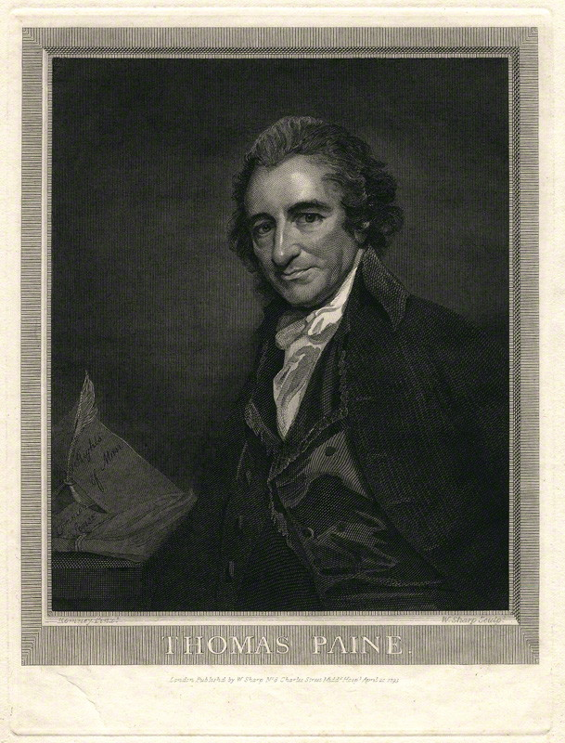
Thomas Paine by William Sharp, after George Romney, engraving, 1793 – National Portrait Gallery

The commissioning of Romney’s portrait was a modern gesture. For centuries monarchs and aristocrats had been using portraits of themselves to advertise their power, wealth and possessions, but the purpose of Paine’s portrait was to demonstrate his intellectual authority. Paine had been savagely ridiculed in cartoons, burnt in effigy and generally demonised, but now through the medium of the engraving he was presented to the public as a sympathetic, reasonable-looking, intelligent man. He wears a coat, waistcoat and cravat, and presents – dare one say it – a respectable appearance. To coin the obvious phrase, Romney put the best face on his subject. Paine looks directly at the spectator with a friendly smile on his face, his eyes alight with intelligence; he presents himself as a reasonable man, a man of common sense with no more than arguments and ideas to offer. To his right, apparently propped up, is a paper bearing the title “Rights of Man” and beside it a bundle of papers entitled “Common Sense”; these are his engines of subversion – innocuous pieces of paper.
Romney’s lost picture was by no means the only portrait made of Paine. Moncure Conway, the American writer whose account of Paine, published in 1892, is still regarded as “the key reference work”, added an appendix to his biography in which he gives an account of the various portraits of his subject. He opens with a description of Paine:
He had a prominent nose… (His) mouth was delicate, his chin also; he wore no whiskers or beard until too feeble with age to shave. His forehead was loft and unfurrowed; his head long, the occiput (the back part of the head) feeble. His complexion was ruddy – thoroughly English.
In another appendix Conway reprints a sketch of his life written by Madame Marguerite Bonneville, who looked after Paine for much of his final years in America. Her sketch contains this charming snapshot of Paine:
“Thomas Paine was about five feet nine inches high, English measure, and about five feet six French measure. His bust was well proportioned; and his face oblong. Reflexion was the great expression of his face; in which was always seen the calm proceeding from a conscience void of reproach. His eye, which was black, was lively and piercing, and told us that he saw into the very heart of hearts of any one who wished to deceive him. A most benignant smile expressed what he felt upon receiving an affectionate salutation, or praise delicately conveyed. His leg and foot were elegant, and he stood and walked upright, without stiffness or affectation. He never wore a sword nor cane, but often walked with his hat in one hand and with his other hand behind his back. His countenance, when walking, was generally thoughtful. In receiving salutations he bowed very gracefully, and, if from an acquaintance, he did not begin with "how d' ye do?" but, with a "what news?" If they had none, he gave them his.
Many people who met him commented on the striking quality of his eyes. General Charles Lee said in 1776 that “he has genius in his eyes”. Someone who met in France commented that “his eyes are full of fire”, and someone else who met him in later life said that “his dark eye retained its sparkling vigour”.
There are many images of Paine, including numerous caricatures, but Conway claims there are eleven original portraits, besides a death-mask, a bust and a profile on a seal. After reviewing them he comes to the conclusion that “the truest portrait of Paine is that painted by John Wesley Jarvis in 1803”, a picture that is now in the National Portrait Gallery in Washington.

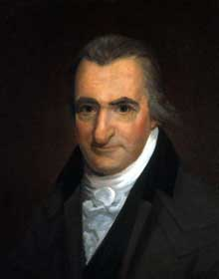
Thomas Paine by John Wesley Jarvis, c. 1805, Oil on canvas

Once again a little caveat must be entered. Conway was a great admirer of Paine; indeed, one might almost say he hero-worshipped him. The image captured by Jarvis was more than a little flattering, in that by 1803 Paine’s drinking and ill health had by all accounts left their marks on his face, inflaming and swelling his nose and covering his skin with blotches and spots. Nor was he accustomed to dress in the gentlemanly style depicted in the portrait: white cravat, ruffled shirt front, and greatcoat with double cape collar.
Jarvis was well acquainted with both Paine’s appearance and his character, for Paine stayed with him in his bachelor’s quarters in Church Street, New York, from November 1806 until the spring of the following year. Jarvis was then in his mid-twenties, and despite their age difference, the two men got on well, perhaps because Jarvis was convivial, eccentric, a great story teller and a drinker. He was, however, concerned that Paine should recant his views on religion. On one occasion his attempts to reform his guest prompted a memorable reply from Paine. “I do not know what I may do when I am infested by disease and pain. I may become a second child; and designing people may entrap me into saying anything; or they may put into my mouth what I never said.” But until then, Paine insisted, he would stick to his “already written opinions”. He was referring to his book The Age of Reason.
For some reason Conway does not mention a miniature of Paine that John Trumbull, an American painter, made for Thomas Jefferson in 1788 when he and Paine were both in London. When he received it Jefferson wrote to Trumbull, saying, ‘I am to thank you a thousand times for the portrait of Mr. Paine, which is a perfect likeness.’
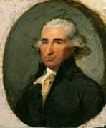
Thomas Paine by John Trumbull, miniature, 1788

Although the miniature gives Paine the nose for which he was famous, it does not bear a close resemblance to the face that Jarvis depicted. The Jarvis portrait is full of character and animation, unlike the miniature which is rather stiff and formal. It may well be, of course, that Jefferson was being polite to Trumbull, who had presented his miniature to him as a gift. He was certainly sufficiently pleased with it to hang it in his house at Philadelphia among his collection of portraits, whom he called “American Worthies”.
When Jefferson died the Trumbull miniature was packed up and sent away for storage. It then disappeared and was not found again until 1955 when it was discovered that canvas had been vandalized: the eyes had been blinded and the chest had been stabbed. No one knows how this came about, though it has been suggested that it was a child’s mischief. At all events, it is good to know that it now hangs once again where it belongs in the parlor at Monticello.
The morning Paine died on 8 June 1809, Jarvis moulded his head in plaster. According to Mme Bonneville, “Death had not disfigured him. Though very thin, his bones were not protuberant. He was not wrinkled, and had lost very little hair.” Jarvis later used his death mask to make a bust of Paine, which must be counted an accurate likeness. Despite its grisly origins, the expression on the face of the bust seems expressive and full of character.

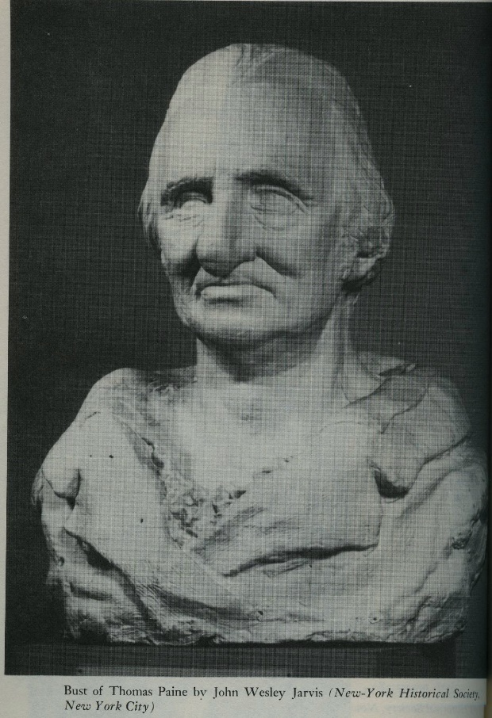
Thomas Paine by John Wesley Jarvis, marble bust, 1806-1807.

We do not know if Wheeler studied the Jarvis death mask; probably not, judging by his account of Paine’s face in his statue. In any case, Wheeler quite rightly wanted to depict Paine in his full vigour, and not the broken old man that he appears to have become during the final years of his life. Had he wanted to refer to it, Wheeler would have found no difficulty in locating one, since plenty of copies have become available in the UK; for example, the Ancient House Museum in Thetford has a copy on display, and so does the Thomas Paine Hotel. (Fanatical devotees of Paine who are eager to possess their own masks can turn to eBay, where they are occasionally offered for sale. At the time of writing (September 2014) an example was available for $75.)

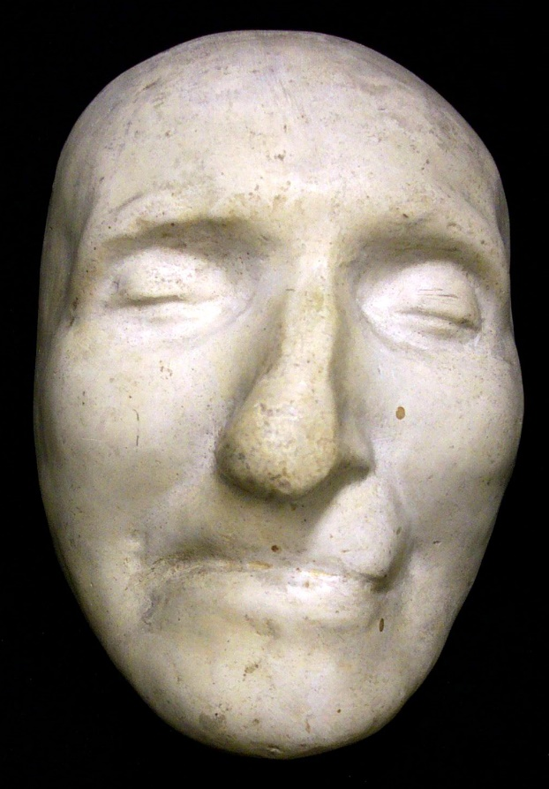

The most immediately noticeable feature of the mask is its nose, which has been displaced and bent to the left, as one looks at it. There also appears to be an unwanted indentation on the upper lip. These distortions were probably the result of hasty, clumsy or inexperienced work on Jarvis’s part, though in fairness to him it must be said that they are a common feature of death masks resulting from the weight of plaster or wax resting on the flesh. Nonetheless, his death mask, as with any death mask, exercises a certain fascination because of its intimate and immediate connection with the dead person.
Original masks can usually be identified by the detailed quality of the impression: pores, lines, creases, even hairs are visible on the delicate, impressionable surface, details that get lost when casts are made from the original, and then casts of casts. Thus, the mask gives an opportunity of getting as close as it is possible to come with the physical entity of a person who has been dead and buried (and in Paine’s case unburied) long ago. It represents a direct, if ghoulish physical link with the dead person; it has an unarguable authenticity. On the other hand, it has only limited value as a portrait of the living person, since by definition a death mask derives from the moment when the subject ceases to be and in most cases is likely to bear the marks of disease or age and decay, distortions that detract from its value as a likeness of the subject in his or her prime.
It is not possible to tell if Charles Wheeler studied the Jarvis portrait or other portraits in America before he began work on his statues. In his autobiography he reveals that he took a trip to New York in February 1963, but he makes no mention of researching images of Paine. However, among the many images available to him in England there was one that appears to have offered a close likenesses, though admittedly of Paine in old age. This is a stipple engraving that dates from 1803, when Paine was 66 and well past his prime. The caption states that it was “Engraved by James Godby from an Original Drawing done from the Life in America in 1803.” There is a copy in the National Portrait Gallery, London.

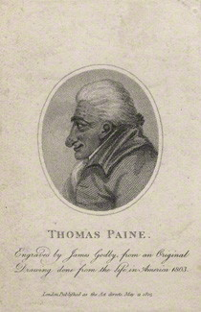

I believe that anyone who cares for Paine will be touched by this engraving, though it hardly shows him in a flattering light. Age was not kind to Paine. It bears a strong resemblance to the Jarvis portrait, but shows the same man ten years later, his ruddy English complexion now the product of alcohol rather than fresh air, his nose swollen and disfigured with carbuncles, his skin blotched with purple spots. Though not visible, his teeth were said to be in poor condition and discoloured. A kinder account said he had “a red and rugged face … which looks as if it has been much hackneyed in the service of the world”. His nose was said to “correspond with the fiery appearance of his cheeks”, while his nose was “like a blazing star”. This is the face of a man in poor health, who has suffered both physically and mentally from illness and the terrors associated with lengthy imprisonment in what was effectively death row (the Luxembourg Palace). It shows a man who was no longer careful about his appearance, who did not have a partner, and whose relations with the people who cared for him were always difficult. But for all that, the face is illuminated by genial good spirits and lively intelligence, and suggests someone who is likely to be good company, at least when sober, someone who is still full of combative opinions.
As a footnote to this review of the portraits, I would like to mention the silhouette that exists, though I’m not sure where the original is kept. It is attributed to John Wesley Jarvis, who was known to be adept at this form of spontaneous portrait making.

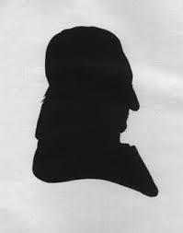
I include it here for the sake of completism; it does not provide much information, beyond confirming what needs no additional confirming – the generous proportions of our hero’s nose.
*
So, now we must return to what we have – Wheeler’s take on the Sharp version of Romney’s original.
Wheeler was commissioned to sculpt it by Joseph Lewis, an American, who is acknowledged on the statue’s pedestal: Presented to the people of England / by the Thomas Paine Foundation / New York U.S.A. secretary Joseph Lewis / sculptor Charles Wheeler P.R.A. / dedicated June 7. 1964.
Joseph Lewis (1889-1968) was a remarkable man. Born a Jew, he abandoned his family’s faith in favour of atheism, crediting Paine’s Age of Reason as one of the influences that prompted his conversion, if that is the right word. His loyalty to Paine was lifelong and obsessive; for example, he could not be shaken in his belief that Paine was the true author of the Declaration of Independence, a conviction he advanced at every opportunity. In 1928 he became the president of The Freethinkers of America and for the rest of his life he worked as America’s most energetic and outspoken activist on behalf of atheism. Somewhat in the spirit of Paine, he published a series of modestly priced books and pamphlets designed to be read by ordinary people about such controversial subjects as contraception, as well as freethinking and atheism. Unlike Paine, he proceeded to make a fortune out of his publications, acquiring an estate in Westchester County, New York, an apartment on Park Avenue and a house in Miami Beach. Lewis also wrote books himself and their titles indicate his lifetime’s agenda; among them were The Tyranny of God (1920), The Bible Unmasked (1926), and Should Children Receive Religious Instruction? (1933). He did not lack courage. In 1954, when McCarthyism was at its most virulent, he published An Atheist Manifesto to refute the idea that atheism was un-American.
In his reverence for Paine, Lewis appears to have responded literally to a remark supposedly made by Napoleon in 1802. The First Consul invited Paine to dinner and reportedly told him that he always slept with a copy of Rights of Man under his pillow, adding that he would be honoured to receive his future correspondence and advice, a remark he later regretted. According to the same witness, another Englishman, Napoleon also said that every city of the universe should erect a golden statue of Paine. Every city of the universe! The youthful emperor-to-be was not above teasing, but perhaps his tone was lost on the two Englishmen. Despite his involvement in French politics for the previous ten years, Paine’s French was still poor and he continued to need a translator. We do not know if Paine took this flattery seriously or not (he probably did, since his self-importance was boundless), but Lewis took it very seriously. He commissioned three statues of his hero, including the one that stands in Thetford. Following Napoleon’s extravagant proposal, he paid for them to be covered in gold leaf, a gesture that might have gratified Paine’s vanity, but was surely at odds with his principles.
The first of these statues was carved by Gutzon Borglum, the American sculptor famous for blasting the faces of four presidents into Mount Rushmore, South Dakota. Commissioned by the French-American Thomas Paine Memorial Commission, though funded by Lewis, Borglum completed an eight foot statue of Paine, which was to be unveiled in Paris on the 200th anniversary of his birth in January 1937. Borglum shipped his plaster cast to France in good time. It was to be cast in bronze by the celebrated foundry run by the Rudiers, father and son, where many of Rodin’s pieces had been made. Borglum flew to Paris to take part in the unveiling ceremony, but for some reason work at the foundry was delayed and the event had to be postponed. Further delays ensued. Then the Second World War began and Paris was occupied by the Nazis. The Rudier foundry was looted, but the soldiers overlooked the Paine bronze, which had been stored in a small, obscure room. It came to light after the war and was finally given a place in Paris in the Parc Montsouris, 14th Arrondissement, where it stands to this day. It was unveiled in all its gilded glory in 1948 on Paine’s birthday, January 29, 1948, a glittering tribute to Lewis’s persistence as much as its subject’s prestige.
Lewis’s choice of sculptor was no doubt influenced by Borglum’s status at the time. By 1936 the faces of Washington and Jefferson had been blasted out of the granite on Mount Rushmore, and the faces of Lincoln and Roosevelt were almost completed. These achievements made Borglum the most famous sculptor in America. However, Lewis and the French-American Thomas Paine Memorial Commission must have been more familiar with Borglum’s than his politics. A one-time sympathiser of the Ku Klux Klan, Borglum had embraced white supremacist views: in the 1920’s he believed that the ‘Nordic races’ were the backbone of America, but feared that their ‘race purity’ was being destroyed by ‘mongrel blood’. These were hardly sentiments that Paine, a pioneer abolitionist, would have endorsed.
Of all the Paine statues Borglum’s is the most conventional, the least lively. Whether under instructions or not, Borglum decided to portray Paine in an uncharacteristic pose. Turning to his left, with his right hand upraised and a book clasped in his left, he appears to be making a speech, though his mouth is closed. From all accounts Paine was not a good public speaker, and was much happier addressing his public through the medium of pamphlets. In any event, the pose is formal and dignified, even statesmanlike, none of them qualities associated with the rebellious Paine.

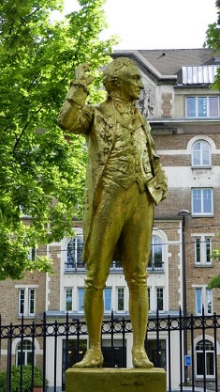

Lewis attended the unveiling ceremony, while the French recipients of his generosity were represented by the Vice-President of the Paris Municipal Council and the Prefect of the Seine Department. Lewis delivered a marathon speech, during which his audience was required to show more than usual powers of endurance because it poured with rain. His hero-worship of Paine was at its most hyperbolic: Paine, he declared,
wore no crown of thorns yet suffered the pangs of crucifixion by being banished from the country of his birth, imprisoned in the land whose liberty he defended, and denied citizenship and the right to vote in the Republic he created. He claimed no relationship with the supernatural, but if ever there existed upon this earth an apostle of the human race, his name was Thomas Paine!
Lewis also commissioned and paid for the much more impressive statue of Paine that stands in Burnham Park, Morristown, New Jersey and was unveiled in 1950. In this case the sculptor was Georg Lober (1892 – 1961), who had been an apprentice of Gutzon Borglum and was then serving on the New York City Municipal Art Commission as its executive secretary. He later became famous for carving a statue of Hans Christian Anderson that was placed in New York’s Central Park. The great story teller is seated on a bench, with a book on his knee, his top hat beside him and a duck at his feet. The statue is an open invitation for children to sit beside him, or even on his knee, and it makes a nice, if quite coincidental link with Thetford’s statue of Captain Mainwaring.
Lober’s statue of Paine captures one of the great incidents of his life, the one that contributed more than any other to his tremendous reputation in the United States (which prevails and bears no comparison to his modest standing in the country of his birth.) Perhaps under Lewis’s instructions, Lober chose to depict Paine as he writes the pamphet that remains his most famous work in America, the first of his essays collected under the title American Crisis. It was published in the December of 1776 at a particularly desperate juncture in the American War of Independence when the revolutionary cause seemed all but lost. Washington’s troops had retreated across the Delaware River, and the British were gathering their troops for what threatened to be an attack on Philadelphia. A victory for the colonial forces at that moment might well have jeopardised the entire revolution. Paine wrote his essay in order to revive American morale and reinvigorate the spirit of independence. “I came to Philadelphia on public service ... and seeing the deplorable and melancholy condition the people were in, afraid to speak and almost to think, the public press stopt, and nothing in circulation but fears and falsehoods, I sat down and in what I may call a passion of patriotism, and wrote the first number of the Crisis.”
With a print run of 18,000 copies it was published as an eight-page pamphlet, which was immediately pirated and sold up and down the Atlantic coast, making its ultimate readership impossible to calculate. (Typically, Paine took no payment on condition that the publisher gave
his edition the lowest possible price.) It is very rare that an intervention made by a writer with his pen changes the course of events, but this appears to have been such an occasion. At dusk on Christmas Day 1776 Washington ordered his officers to assemble the soldiers in small squads and read them Paine’s words. Familiar though they are to Americans, they are worth quoting again:
“These are the times that try men’s souls. The summer soldier and the sunshine patriot will, in this crisis, shrink from the service of their country; but he that stands it now, deserves the love and thanks of man and woman. Tyranny, like hell, is not easily conquered; yet we have this consolation with us, that the harder the conflict, the more glorious the triumph. What we obtain too cheap, we esteem too lightly: it is dearness only that gives every thing its value…”
The next morning Washington and his army made its famous crossing of the Delaware River, rowing flat-bottomed boats through the ice, and defeated the Hessian mercenaries employed by the British in the Battle of Trenton. This American victory changed the course of the war, and Paine can reasonably be claimed to have made a decisive contribution.
(It would appear that no less a figure than Barack Obama shared this opinion. In his inaugural speech made on January 20, 2009, he directly referred to this incident in his closing lines, though without mentioning Paine’s name.
“So let us mark this day with remembrance, of who we are and how far we have traveled. In the year of America's birth, in the coldest of months, a small band of patriots huddled by dying campfires on the shores of an icy river. The capital was abandoned. The enemy was advancing. The snow was stained with blood. At a moment when the outcome of our revolution was most in doubt, the father of our nation ordered these words be read to the people:
"Let it be told to the future world ... that in the depth of winter, when nothing but hope and virtue could survive... that the city and the country, alarmed at one common danger, came forth to meet [it]." In the face of our common dangers, in this winter of our hardship, let us remember these timeless words. With hope and virtue, let us brave once more the icy currents, and endure what storms may come. Let it be said by our children's children that when we were tested, we refused to let this journey end, that we did not turn back, nor did we falter; and with eyes fixed on the horizon and God's grace upon us, we carried forth that great gift of freedom and delivered it safely to future generations.” (The quotation is from American Crisis 1.)

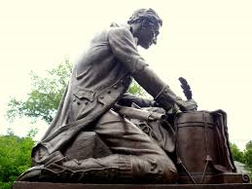

In his statue Lober has chosen to dramatise the moment when this historic pamphlet was composed. The figure of Paine wears a long-skirted coat, his trousers tucked into knee-high boots, his shirt open at the throat. A musket lies across his lap, a tricorn hat is near his feet, and he is kneeling on one knee as he writes with a quill pen on a piece of paper laid on a drumhead. Paine’s legendary opening rallying cry has been incised on the paper: “These are the times that try men’s souls”.
Paine may well have made notes for his essay as he walked the thirty-five miles from the battlefront at Trenton back to Philadelphia, where the essay was completed and printed. For all we know, he may have stopped somewhere and used a drum as an improvised desk, but for Lewis the statue seems to have been a literal representation of an actual incident, of which there is no record.

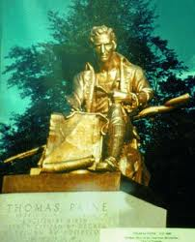

It was dedicated on July 4, 1950 and as usual Lewis was on hand to make a speech. The rain did not fall on this occasion, and his oratory was unrestrained. For the benefit of his patient audience described the situation in which Washington and his army found themselves in December 1776; it looked “bleak through clouds of despair”, he told them in his inimitable style. Next he conjured up a picture of Paine in the very act of writing. Immune to the winter's cold, with his musket across his knee, and wearing Washington's coat, he penned what Lewis called his “flaming words of inspiration”. (It would be interesting to know where this legend, especially the detail of Washington’s coat round our scribe’s shoulders, circulated, except in Lewis’s head.)
Finally, he rose to his climax:
“It was in response to the agonizing cry of George Washington, the Commander-in-Chief of the Revolutionary Army, as well as to the groans of despair from the soldiers themselves, in this critical American Crisis that one man, AND ONE MAN ALONE -- Thomas Paine -- rose to the supreme heights of heroic action, and by the eloquence of his inspiring words and by his own unselfish devotion to the cause of Human Freedom, became both the Creator and Saviour of the American Republic…It was not the Maid of Orleans that turned the tide, it was the Man from Thetford.”
Ah! The Man from Thetford!
For all the ridiculous exaggeration that overtook Lewis whenever he opened his mouth on the subject of Paine, Thetford can surely take pride in the fact that one its sons did indeed become “the creator and saviour” of the American republic. There are many reasons to invest the Man from Thetford with his capital letter, and his response to the crisis of December 1776 is certainly one of them.
When commissioning a statue for England, Lewis chose Sir Charles Wheeler (1892 – 1974), who had been knighted in 1958 and was President of the Royal Academy at the time. He was, in fact, the first sculptor in the Academy’s history to hold that position. (As president he was briefly notorious in 1962 for presiding over the sale of a cartoon by Leonard da Vinci, The Virgin and Child with St. Anne and St. John the Baptist, in order to raise funds to support the Academy.) His professional seniority in itself may well have swayed Lewis, just as Borglum’s prestige had swayed him earlier, but he would also have been influenced by the fact that Wheeler had a long record of specialising in architectural sculpture as well as portraiture. He produced many sculptural likenesses and felt strongly enough about this branch of art to assist in the founding of the Society of Portrait Sculptors in 1953, becoming its first President. During his career he sculpted portraits of the great and the good – Yehudi Menuhin, Montague Norman (governor of the Bank of England), Lord Hives (chairman of Rolls Royce), Admiral Vian, Lord Jellicoe, T. E. Lawrence, Sir Donald Wolfit, and so on. His most illustrious sitter was the Queen, who granted him six sessions of an hour each in 1960. His large-scale architectural sculpture could be seen on many famous public buildings in London, including several stone statues and bronze pieces for the Bank of England, stone tigers on India House, a bronze springbok on South Africa House, figures representing Earth and Water on the Government offices in Whitehall (each made from 40 ton blocks of Portland stone), and two bronze fountains – groups of mermaids and tritons – on the Jellicoe memorial in Trafalgar Square.

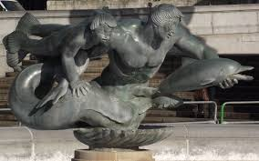

After he died in 1974 his obituaries drew attention both to his achievements and his agreeable personal qualities: ‘A charmingly modest person of gentle conversational manners, he could be courageously forthright in condemning the worst aspects of modernist art… The overriding sense that all who worked with this unusual personality must feel is one of affectionate gratitude… His physical stature was Lilliputian against his monuments. He could only described as a dapper little man with a bow tie; however, Wheeler’s unassuming charm and sensitivity transcended even his monolithic telamons on the Bank of England… Sir Charles looks almost fragile until you notice his large, muscular hands.”

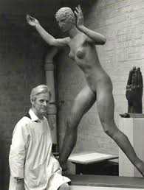

At the time when Lewis invited Wheeler to make a statue of Paine he was, with Jacob Epstein, the most famous figurative sculptor of his generation. However, he was also by then distinctly old-fashioned. Though never an anti-modernist like Alfred Munnings, he was a sculptor whose work had frequently “symbolised the state, and national and imperial confidence,” to quote Sarah Crellin, author of a beautiful monograph about his work. In summing up his career she writes that he was an “Academic Humanist”, who had worked in a period when it was possible to manifest the spirit of a heroic vision in civic sculpture. He was a solid establishment man and therefore not the ideal choice for Paine, whose own “heroic vision” was essentially anti-establishment. To be fair to Wheeler, he appears to have brought his customary professionalism to the job, but, as we shall see, his lack of instinctive sympathy with Paine’s ideas meant that he was unable to invest his statue with the same epic monumentality that he had bestowed on his tritons and telamons, or on his steadfast duffel-coated sailors that stood outside the Royal Naval Memorial in Chatham.

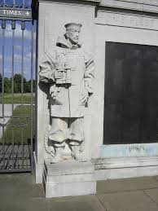

When Lewis originally proposed a statue of Paine in England he did not have Thetford in mind.* In 1962 he wrote to the London County Council asking if they would help to find a suitable site in London. In its reply The LCC pointed out that London was well endowed with statues, but suggested as an alternative the birthplace of Paine, which was then undergoing its great expansion under the so-called London overspill scheme. Copies of these letters were sent to the town clerk and the Borough Council of Thetford decided to invite Lewis to visit the town. Lewis travelled to Thetford where he was met by the mayor and other councillors and it was provisionally agreed that the statue would stand in the Market Place. Lewis said that he proposed to commisson a statue from Sir Charles Wheeler made of bronze and covered in gold leaf, which would stand on a pedestal of Portland stone bearing various quotations from Paine’s writings. He estimated that the total cost would be about $50,000. (According to the website http://www.dollartimes.com/calculators/inflation.htm, $50,000 in 1963 would have the buying power of $383,304 in 2014, which converts to £240,022.) Lewis placed only one condition on his gift to the town, which was that he should be allowed to make the dedication speech at the unveiling. The town clerk assured him that the Council would be delighted to agree, but “was somewhat taken aback when he confided that the dedication speech was already written and would take about three and a quarter hours to deliver.”
This was not the only problem that the proposed statue confronted. The local branch of the British Legion objected to the siting of the statue in the Market Place where it would be close to the War Memorial, which would be inappropriate, they argued, because Paine had fought on the side of the American colonists against the British Army. On the face of it, Paine’s allegiance to the rebels in the American War of Independence may not seem to be directly offensive to the memory of those who died nearly two centuries later in the two World Wars, but at that time the army was a much bigger presence in Thetford than it is today and loyalist feelings ran high. In any case, a solution was at hand. The forecourt of King’s House was being redesigned and out of respect to the feelings of the British Legion the council decided to place the statue in front of the House.
A second and much more belligerant objection was lodged by Councillor John Mayes, who was a longstanding and outspoken critic of Paine, whom he accused of being a traitor and a rascal who had deserted his wife. Interviewed by the press, he said, “The man was a bloody anarchist, yet we’re erecting a statue to him’. He added, ‘I’ve been against it all along and I stand by what I said at the beginning – that I will resign if that statue goes up.” Describing himself as “the truest-blue, dyed-in-the-wool Tory”, Mayes declared that he was shocked and surprised that his fellow Tories on the council were supporting the erection of a statue of “a revolutionary”. When the time came he also objected that the ratepayers of Thetford were being required to stump up £150 to provide refreshments for those invited to attend the unveiling ceremony. (The town clerk records that Mayes told him he would only agree to the statue if it was placed at the council’s sewage disposal site, a concession that he does not seem to have made public.)
Mayes’s point of view appears not to have been representative of more than a minority in the town. More common was the attitude of Fred Burney, manager of the Bell Hotel, who confessed that he didn’t know who Paine was before the statue had been proposed, but believed it would bring Americans to the town.
Meanwhile, the council deputed the town clerk to persuade Lewis to reduce the length of his speech and to request that the statue be left as a bronze without gold leaf. Lewis was adamant that the statue should be gilded in order to fulfil Napoleon’s dream. However, he did promise to give some thought to his address, though he “was not optimistic that he could shorten his speech to any great extent and still do justice to so great a man as Thomas Paine.”
The statue was finally delivered to the town three days before the unveiling ceremony due to be held on Sunday, June 7 1964. While it was suspended from a crane above its pedestal in King Street, a polythene envelope containing the names of the subscribers who paid for the work was placed on the pedestal and sealed in forever as the statue was lowered and fixed in position. The statue was covered in a white sheet and, to protect it from vandals and protestors, the borough engineer arranged for a member of his staff to stand guard at the site until the unveiling. Within fifteen minutes a formal letter of resignation from Mayes arrived on the town clerk’s desk.
More than 100 honoured guest assembled for the unveiling ceremony, including representatives of the American and French ambassadors, the US Air Force and the London County Council. Lewis was accompanied by his wife and son and members of the Thomas Paine Foundation of America. He reassured the town clerk that he had been able to shorten his speech and still pay tribute to his hero; he now expected to speak for a little under three hours. The press and television, which had followed the story of Mayes’s threatened resignation, were present in large numbers, and several hundred people also gathered in King Street to witness the event, forcing the police to close what in those days was the town’s main highway. Bertrand Russell sent a short message of support, which included a splendidly vivid, though probably apocryphal detail. He reminded people that Paine had been so feared in Britain that William Pitt, the prime minister, had order that the soles of soldiers’ boots should be stamped with the initials T.P. so that each time they took a step they would be stepping on Tom Paine.
The mayor opened proceedings by making a short speech expressing gratitude on behalf of the town to Joseph Lewis, secretary of the Thomas Paine Foundation of America, whose generosity and enterprise had made the statue possible. He then called on Lewis to give the dedication address before unveiling the statue.
The 75 year old man, his flowing white hair tossed by an ominous breeze, stepped forward under a darkening sky and began his peroration. After he had been speaking for twenty minutes or so, there was a roll of thunder and a heavy rain storm drove everyone to run for shelter. Wheeler was observed scampering across the forecourt of Kings House with an upturned chair over his head.
Lewis resumed after quarter of an hour, only to be stopped a second time by another torrential fall of rain. When he began again for the third time he feared that his listeners might have lost the thread of his eulogy and he embarked on a brief summary of what he had already said. Sensing that the patience of the drenched audience might be running out, his wife interrupted him, saying, “Joseph! You must bring your speech to a close.” He turned to her and replied, “My dear, I have travelled 5000 miles to pay tribute to this great man and I must complete my task.”
He suffered two more interruptions from the rain, but he was made of stern stuff, even if his audience was not. Many had gone home, while the dignitaries were forced to shelter under umbrellas or in King’s House, catching what they could of his unstoppable words. With his grandson’s jacket round his shoulders, he persisted in talking through the lighter showers, and soldiered on. (Though an atheist, he might have been forgiven for reading divine exasperation in the downpours that accompanied his efforts to honour the author of The Age of Reason.)
“I have come to honour Thomas Paine and not to bury him,” he said. “I have come to give the people of Thetford a living memorial to one of the noble sons of man and not a monument to the dead.” Striking a Churchillian note, he declared “Never has so much been done so unselfishly for so many for such little credit. Nowhere has there been such a disgraceful show of ingratitude mixed with religious hatred as there had been against Paine… I would rather be the sponsor of this memorial to Thomas Paine than hold high political office.”
After he had spoken for 90 minutes in all, he finally brought his remarks to a halt, and the time came to pull the canvas drapes away from the seven and a half foot-high statue. The rain relented and the town’s 18-carat gold hero, glittering in the sunshine, was presented to its sodden citizens.
*
Let us turn back to the statue itself, or rather the pose that Wheeler has imposed on his subject.

There is no record of Wheeler’s having seen either of the predecessor statues commissioned by Lewis in Paris or Morristown; if he did study them, he did not choose to follow their lead. Nor does his head bear much similarity to the engraving by Sharp, from which he must have worked, despite his reference to the Romney portrait in his speech at the unveiling. Alone among the sculptural representations of Paine, his statue has a touch of caricatured exaggeration about it, which adds to its sense of vigour and demonstrates a refreshing lack of veneration. However, it has to be said that the pose in which he has cast Paine is very curious, making it perhaps the oddest, most eccentric statue he produced in his entire oeuvre.
The figure forms a sinuous shape, driving a sense of movement through the right arm, across the chest, and down the left leg. The head, reinforcing the flow of movement, is turned to look eastwards down King Street, while the right arm is held aloft and extended in the other direction, a quill pen in the hand. In his left hand Paine holds a huge, leather-bound book. At first sight, it looks as if Paine is about to throw his pen like a spear, but he is holding it in a delicate grip, suitable for writing not hurling. There is something awkward about the pose and closer inspection reveals the cause: the statue is raised on its toes and both heels are off the ground. The result is a position that is quite unnatural, and would be painful to sustain for more than a few seconds. (Try it for yourself.) Why did Wheeler choose such a stance?
It is true that a kind of dynamism is generated by this sinuous, twisted pose; Paine looks both energetic and combative, which is appropriate. However, this effect is mitigated to some degree by the combined heights of the plinth and statue, because the view from the pavement below has the unfortunate effect of exaggerating the size and weight of the calves and thighs, while seeming to diminish the size of the torso and head.
Wheeler published his autobiography, High Relief, in 1968, and presumably wrote the book after sculpting his Paine statue, but he makes no mention of it. Nor does Sarah Crellin supply any background detail to the creation of the work in her study of Wheeler. We can, therefore, only speculate when it comes to the influences that may have been working on Wheeler as he selected the pose in which to place his version of Paine. There is one clue that may be worth pursuing. During his visit to New York in February 1963 he was shown the sights by his brother, but was not impressed; the UN Headquarters, for example, was “ugly” and “hopelessly depressing”. He studied Lober’s sculpture of Hans Anderson in Central Park, but dismissed it as “far too pictorial”. However, the “one ray of pleasure” in the trip was the chance to see a bronze replica of what he calls the Thundering Zeus. He knew the original, he writes, because he had seen it the National Museum in Athens soon after it had been rescued from the sea bed. He is undoubtedly referring to what is more commonly known as the Artemision Bronze, which is currently exhibited in the National Archaeological Museum of Athens.

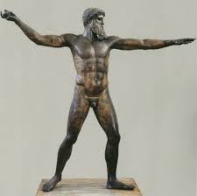
The Artemision Bronze, National Archaeological Museum of Athens.

It is now generally accepted by scholars that this magnificent sculpture represents Zeus rather than Poseidon. The matter would have been immediately settled if the object held in the figure’s right hand had also been discovered when it was excavated from a shipwreck in 1926 and 1928. Unfortunately, a diver was drowned in 1928 while working on the underwater site and further exploration was halted. If the statue does indeed represent Zeus then the missing object will have been a thunderbolt. (If Poseidon, a trident.)
There are many obvious differences between this nude statue and Wheeler’s portrayal of Paine, but one similarity is worth noticing. As with Paine, the god’s torso is open and forward-looking, while the head is held in profile, turned to the left. The weight is on the left foot, which is squarely placed on the ground and turned in the same direction as the head and outstretched left arm. The right heel is raised and the foot is poised on its toes, adding to the impression that the god is taking aim. It is a supremely heroic pose, a moment of powerful concentration as the god gathers his forces before violence is unleashed. Zeus looks in the direction of the target that will be struck by the missile in his upraised right arm. Since Wheeler’s choice of pose, with its dynamic shape, also suggests throwing rather than writing, it is possible that he had the Artemison Zeus in mind when, back in his studio after his New York trip, he was designing his statue of Paine. After all, what better way to represent Paine’s pen than as a thunderbolt?
Of course, there is no reason why Wheeler should have drawn on any precedents, classical or otherwise, but for what it is worth I would like to propose one more model that might have had an influence on him.
Wheeler was President of the Royal Academy during the period when he was at work on the Paine statue and he would therefore have been very familiar with the statue of Joshua Reynolds, the Academy’s first president, that stands in the courtyard of Burlington House, home of the Academy.

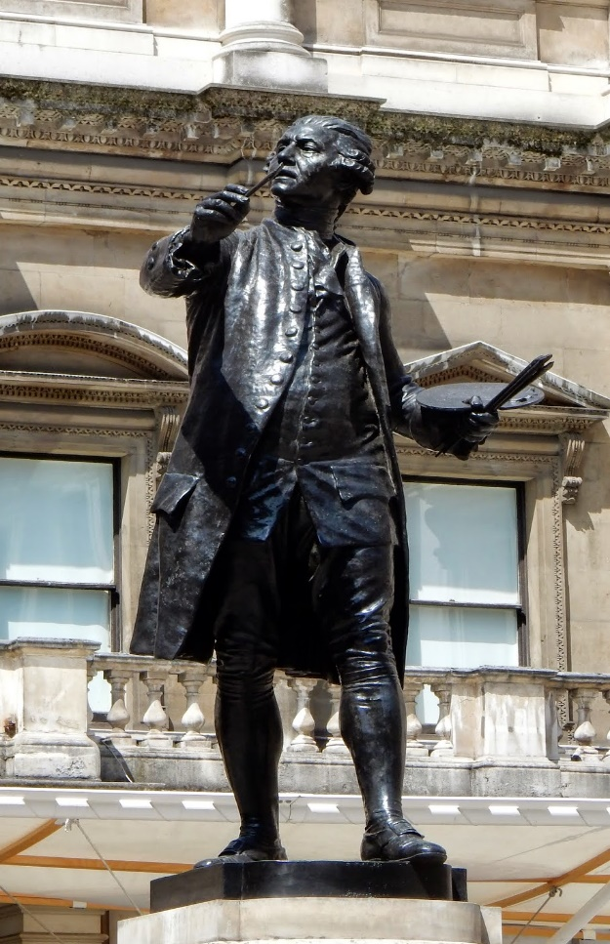
Sir Joshua Reynolds, 1723 – 1792, First President of the Royal Academy , Alfred Drury RA, 1931.

The statue was carved by Alfred Drury, who received the commission in 1917, but did not complete it until 1931. Again, there are many differences between this noble representation of the great painter and Wheeler’s account of the dissident Paine, but one thing they have in common is that they both show their subjects with the tools of their profession in their hands. In his left hand Reynolds holds a bundle of brushes and his thumb is hooked through the hole in his palette. In his right hand he holds the brush he is working with. His feet are planted firmly on the ground and his pose suggests he has just made a stroke on his canvas, and is holding his head back a little to judge its success or otherwise. In contrast with Paine’s raffish appearance, Reynolds is the epitome of dignified success and prosperity. This is a respectful portrait of genius: here is England’s senior painter in the very act of creating a masterpiece. But for all his prestige, he is a professional painter, and he is seen at work. The money that paid for his buckled shoes, frock coat, silk waistcoat and wig was generated by what he is doing with his hands – painting.
Drury’s depiction of Reynolds is solidly representational, with a great emphasis on the gravitas of his subject. Wheeler’s work is all energy and combativeness, which certainly suits his subject. But I wonder if Wheeler did not take something from Drury’s statue. Reynolds is at work on an invisible canvas, which he studies with great intensity. Writers are often shown with their completed works, as in the Sharp engraving, or brooding at their desks , where they do indeed spend the majority of their time. But Paine was both a writer and an activist. Wheeler’s pose suggests a man who is in the thick of the action; he is caught as if by a camera at the moment when he turns away from making a note on an invisible sheet of paper to look back at whatever has taken his attention. The fact that the paper on which he is writing is in mid-air and invisible, though improbable, adds to the impression of urgency. And what is the outcome of this looking and writing? Why, his book, Rights of Man, which he holds in his left hand. Paine looks at the world and is driven to comment on it, to demand that its wrongs be righted, its injustices redressed, its tyrants overturned. And just as the statue impels one’s eye from his pen, to his face, to the book in his hand, it also describes this process of writing, looking, reacting and writing again – or so we might think if we were to put a sympathetic, positive interpretation on Wheeler’s eccentric choice of stance.
A last word on the statue.
At the unveiling Wheeler said that in his effort to capture the spirit of his subject he had drawn inspiration from long talks with Joseph Lewis. (Were there any other kind?) We cannot know if he was merely being polite. Wheeler was hardly a radical himself, and cannot have agreed with many of Paine’s ideas (his anti-royalism, for example), but he does appear to have made his statue in a spirit of respect for Paine. Of all the statues raised in Paine’s honor his is the least reverential, the least concerned to depict him as ‘a great man’, and these are virtues in that his attempt to capture the spirit of the man was also the most ambitious. Instead of the monolithic superhero that we see in Lober’s Morristown statue, we see something much more vigorous, aggressive and challenging, something much closer, therefore, to the original man.
It is therefore unfortunate that he chose to add a flourish to his statue that has caused a great deal of mischief.
In his left hand Paine holds a copy of a book called Rights of Man, a positive tome, with a leather binding and a silk bookmark.
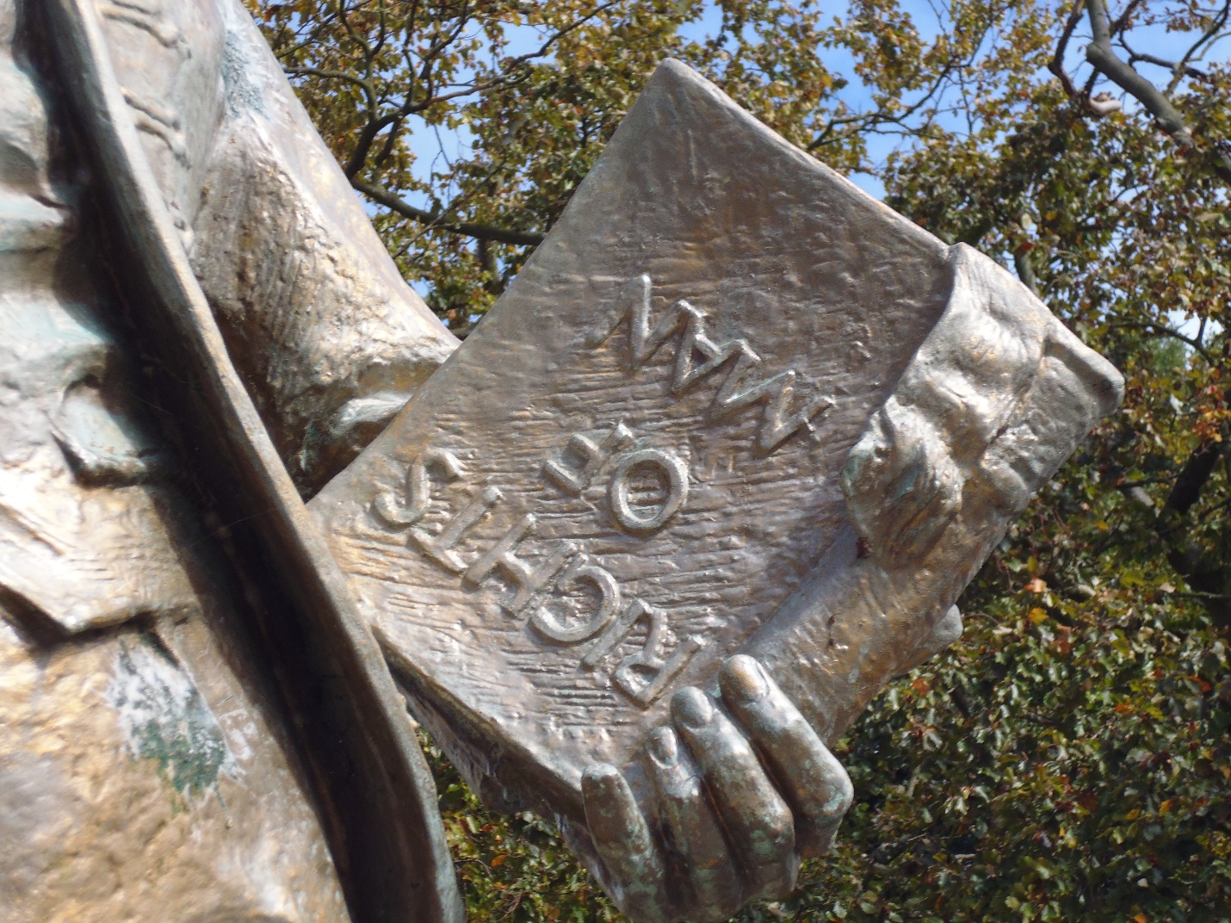

In fact, as Wheeler must have known, Rights of Man was published in two parts, both relatively short, which even when combined would never have amounted to a tenth of the mighty volume Wheeler has created. No matter; perhaps he intended to suggest the symbolic importance of the book by magnifying its size and grandeur, though Paine would not have approved, for he always did what he could to ensure that his books were accessible to poorer readers. But Wheeler did not stop there. For some reason, he chose to emboss the title on the cover in letters that were upside down.
On several occasions Wheeler was asked why he had made this seemingly perverse gesture, and every time he was reported as giving a version of the same unsatisfactory answer (I have never seen a direct quote), which was that he wanted to provoke discussion and debate. Sarah Crellin writes that his gesture was “a deliberate attempt to make the work a talking point, both as a statue and a political subject”. Expanding on this comment, she writes, “The sculptor claimed that too many statues were almost invisible to the public, and that this was a deliberate ploy to engage the viewer with Paine’s work by pulling him up short and making him think.” Alas, his ploy was misconceived. Far from making people think about Paine’s ideas, it has only provoked debate about the mystery of the book’s being upside-down, rather than its contents. At best, his gesture has been seen as an insoluble puzzle; at worst, it has been construed as an attempt to subvert or mock Paine’s great book. However, the prime reason for condemning Wheeler in this context is not for turning the book upside-down, but for placing in Paine’s hand what could only have been a rich man’s possession, something he would have detested.
*
It is fair to say that Thetford took neither Paine nor his statue to its heart. During the years that followed its unveiling the statue was a freqent target of vandals, who sprayed or splashed it with paint, and on Saturdays evenings took pleasure in crowning the great pampleteer’s head with knickers. It was regularly spat on and generally derided. No doubt, most statues of historical worthies that stand in town centres are subjected to similar ignominies, and perhaps, without knowing it, the Thetford vandals were acting in the spirit of Paine, who was always quick to question and, if necessary, desecrate the reputations of great men. But Paine and his statue seem to have been attacked with unusual aggression, more in the spirit of Councillor Mayes than Paine himself. If so, what was his crime? Why did he arouse such animosity? And, for that matter, why has this hatred apparently died down? One explanation may be that in the 1970’s and 1980’s when the statue was regularly abused there were many more soldiers in the town than today, for whom loyalty to the crown was sacred. If Paine was famous for anything, he was notorious for having been an anti-monarchist, and was therefore an object of disgust to these military loyalists. To this day there are people in the town who cannot forgive Paine his republicanism.
Ignorance has also played a pernicious part. I have been told by a pupil who attended Thetford grammar school in the 1980’s that she and her fellow pupils were taught nothing about Paine, their old alumnus, during their time at the school. However, since those days the situation has changed. The turning point came in 2009 when the town celebrated the two hundredth centenary of Paine’s death with an ambitious festival of events, including a Reenactment and Heritage weekend. The Ancient House Museum put on a special exhibition devoted to Paine, and the panels that were designed for the event, illustrating Paine’s life and achievements, may still be seen in the Thomas Paine Hotel. Its proprietor, Gez Chetel, typifies the current enthusiasm for the reinstatement of Paine’s standing in the town. When refurbishing the hotel he decided to capitalise on the hotel’s long-established name and its proximity to Paine’s birthplace by adding references to him in many of the ground floor rooms. He has turned a lobby area into a shrine to Paine by displaying the museum panels and a cabinet containing various items and curiosities connected with Paine, including an eerily illuminated death mask.
Another product of the 2009 celebrations was the Tom Paine 200 Legacy Committee, which was established in order to maintain “the profile of Thetford’s radical thinker in the town”. One of its legacies was the inaugeration of the Common Sense Club, a version of the original Headstrong Club in Lewes attended by Paine when he lived there. With the help of money from the Heritage Lottery Fund the Common Sense Club has organised a five year programme of lectures delivered in the Grammar School on subjects connected with Paine. The last of these were delivered in the autumn of 2014. I attended the penultimate lecture which was given by Professor Jon Mee from the University of York on the subject of Paine’s last days in London in 1792. More than 30 people came to hear him speak, including the mayor, identifiable as always by her chain of office. Mee made no concessions to his non-academic listeners and spoke (at speed) for an hour, not hesitating to go into considerable technical detail when talking about Paine’s dissident contemporaries. At the end he was rewarded with a rousing applause from an audience that was both loyal to its hero and interested in his intellectual and historical context.
However, it has to be admitted that the members of the Common Sense Club and other Paine enthusiasts belong to a very small minority in the town. The most that can be said is that hostility has been replaced by indifference; despite the admirable efforts of Paine enthusiasts, ignorance continues to prevail. I have made it a habit, whenever I find myself standing beneath Paine’s statue in King Street, to ask people sitting on the benches at his feet if they know whom the statue is honouring and, if so, why he is being honoured. My survey has no value beyond the anecdotal, but for what it is worth I have to report that the commonest response from British locals is the response, “I have lived in Thetford all my life and have no idea who he is.”
This lack of knowledge is, unfortunately, not going to be dispelled by pupils currently attending the Thetford Academy, where Thomas Paine goes unmentioned. I broached the matter with the Principal, Adrian Ball, who explained that the demands of the national curriculum left no room for extraneous topics, such as Thomas Paine or, for that matter, the dissolution of the Thetford Priory. To his credit, he regretted it, and could see that overlooking these distinctive historical topics was a serious omission in the upbringing of Thetford’s young. He promised to look into the possibility of correcting it.
The task of making the town aware of Paine and his contribution to our national history is made that much more challenging by a shifting immigrant population, who come from many different countries, each with its own political traditions, heroes and villains, and whose knowledge of British history is unavoidably and forgivably thin. Pitt, Paine, Burke – who are they? But if for that reason alone, it is surely important that newcomers to the town are made aware of its heritage, the heritage to which they are becoming the inheritors. It is doubly important in the case of a town like Thetford, which has suffered in the past from a sense of low esteem, as well as a sense of resentment that it has been unimportant in other people’s eyes. The possession, so to speak, of a great man is something to be proud of, even if he is an equivocal figure.
*
Was Paine, the Man of Thetford, a hero?
What is a hero? The word originates with the ancient Greeks, and was bestowed on a man (usually) who possessed superhuman strength, courage or ability and was favoured by the gods. Heracles, son of Zeus, was the archetype. The hero was essentially a warrior who protected or defended those around him, often by risking his own life. He performed extraordinary feats for the benefit of ordinary people, perhaps to save them from the anger of the gods.
In modern times the word has come to signify someone who “exhibits extraordinary bravery, firmness or greatness of soul… (and is) admired and venerated for his achievements and noble qualities.” We value men and women who achieve excellence by possessing what seems like a superhuman gift, Usain Bolt, for example; but we admire people all the more whose achievements are the product of an extraordinary moral quality, such as courage, self-sacrifice or endurance. During much of the 20th century Scott of the Antarctic was our national archetype. (Has he been replaced? If so, by whom?) Despite his errors of leadership, which may well have cost the lives of the party under his command, Scott continued to be admired as an icon of stoicism and dignity in the face of death. In the United States Martin Luther King has been elevated to the status of national hero, and since his release from prison in 1990 Nelson Mandela has been a hero for much of the world. Both King and Mandela not only championed ideas that changed history, but were willing to stake their lives and freedom in the struggle to see them realised.
Because of Paine’s contribution to their fight for independence, as an activist and the author of Common Sense and The American Crisis, many Americans regard him as a hero. When US servicemen found themselves based near Thetford during the Second World War they were astounded to discover that Paine, a revered figure in their country and a name known to every schoolchild, was ignored in the place of his birth. There was no memorial to him and, worse still, most citizens of his home town were ignorant of his achievements. On the contrary, the reputation that persistently clung to his name was far from heroic; as noted earlier, he was detested in some quarters as a traitor and an atheist.
As we have seen, John Mayes resigned from the council when the decision to accept the Paine statue was taken, and he cited among other reasons that his fellow councillors had refused his plea that Paine’s conviction as a traitor should be engraved under the statue. No doubt, Mayes was being provocative, and never imagined that the council would accede to his request. In fact, Paine was convicted, in his absence, of seditious libel, and I would like to suggest that this is exactly what should have been carved beneath Paine’s statue, along with the other imperishable words quoted from his books. His conviction by the state of a crime that might well have cost him his life elevated him to the status of hero.
The exact nature of Paine’s crime in the eyes of the authorities is worth reading. Here is the indictment:
“Gentlemen, this is an Information against Thomas Paine, for that he, being a person of a wicked, malicious and seditious disposition; and wishing to introduce disorder and confusion, and to cause it to be believed, that the Crown of this kingdom was contrary to the rights of the inhabitants of this kingdom; and to cause it to be believed also, that the Bill of Rights was a Bill of Wrongs and Insults; all tending to bring the government of this country into contempt, and endeavouring to cause it to be believed that the Parliament of this country was openly corrupt in the face of day; and in order to withdraw the affection of the people of this kingdom, against the law and constitution of this country, he the said Thomas Paine, wishing and intending this mischief, did, on the 16th of February 1791 wickedly, falsely, maliciously, scandalously, and seditiously publish a certain book, called ‘Second Part of Rights of Man' signed Thomas Paine, containing many false, wicked, scandalous, malicious, and seditious assertions; with which I will not trouble you, as you will have them from the Attorney General. The Defendant has pleaded, Not Guilty; upon which issue is joined.” (Note that his stated crime was to publish the second part of Rights of Man.)
Seditious libel was, in effect, a supplement to the law of treason that was designed to frighten and suppress intellectuals, as well as their publishers. Indeed, as with Paine, it was more often the publishers who found themselves in court on this charge than the authors they courageously or foolishly chose to espouse. Paine’s trial and the suppression of his book were part of a larger attempt by the government to forestall any possibility of revolution. To quote William Hague from his biography of William Pitt, prime minister at the time, “There had been riots before, sometimes at the same time as the approach of hostilities overseas, but never before accompanied by the rapid spread throughout the nation of radical political ideas inspired by the example of revolution in a neighbouring country.”
For the most part the indictment is accurate, at least in broad terms. Yes, he did wish it to be believed that the Hanoverian dynasty was contrary to the rights of its subjects; yes, he did intend to bring the government into contempt and expose its corruption; yes, he certainly wished to persuade the people to “withdraw” their “affection” (quaint expression) for the law and constitution as they stood. What was not the case was that he wrote his pamphlet wickedly, falsely, and maliciously, though he might have been happy with “scandalously”, and he could not avoid “seditiously”. Nor did he wish to “introduce disorder and confusion”. On the contrary, in the preface to Part Two he explicitly states that it has always been his opinion that “it is better to obey a bad law, making use at the same time of every argument to shew its errors and procure its repeal, than forcibly violate it.’
What appears to have made Part Two of Rights of Man so popular, and therefore so threatening, was the fifth chapter of the pamphlet, which carries the innocuous subtitle “Ways and Means of Improving the Condition of Europe, Interspersed with Miscellaneous Observations”. He opens by stating that whatever form it takes, government ought to have as its object “the general happiness”, and when instead of this it creates and increases wretchedness and poverty it is wrong “and reformation is necessary”. The reforms he proceeds to advocate amount to nothing less than a primitive system of social insurance. He is most concerned to alleviate the poverty of two groups of people, families with large numbers of children and old people no longer able to work. For the first group he proposes the equivalent of child allowance, with the specific intention of making basic education available to every child under fourteen years of age. Thus, poverty would relieved and ignorance would be banished. In the case of families who are not among the poorest, but who nonetheless cannot afford to educate their children, he suggests a scheme whereby the education of this category of children could be funded for six months a year for six years, with an extra provision of “half a crown a year for paper and spelling books.”
As for the elderly, by which a modern reader will be surprised to find he means people over the age of fifty, he proposes an old age pension. And this is to be paid “not as a matter of grace and favour, but of right”, because he or she would only be receiving a proportion of what has already been paid in taxes. ,
Next he proposes a maternity allowance of twenty shillings to every woman who asks for it, a measure that might “relieve a great deal of instant distress”.
One of the pleasures of reading Paine is the sense he conveys that these ideas have just occurred freshly to him, and that he cannot wait to share them with you. The speed with which he lists these welfare proposals has now become positively breathless, as one idea after another seems to cross his mind. As though a new suggestion has only that moment been prompted by the last, immediately after calculating the cost of child allowance, he writes, “And twenty shillings to every new-married couple who should claim in like manner.”
Finally, he proposes a benefit to cover the funeral expenses of poor people who die outside their own parishes, which would otherwise meet the cost.
To this list of provisions he adds one specifically designed for London that would ensure lodging-houses and workshops for immigrants and the unemployed.
At this point it seems imperative to quote Paine own words as he sums up the effects that he anticipates his plan will achieve:
“…The hearts of the humane will not be shocked by ragged and hungry children, and persons of seventy and eighty years of age begging for bread. The dying poor will not be dragged from place to place to breathe their last…Widows will have a maintenance for their children, and not be carted away, on the death of their husbands, like culprits and criminals, and children will no longer be considered as increasing the distresses of their parents…The number of petty crimes, the offspring of distress and poverty, will be lessened. The poor, as well as the rich, will then be interested in the support of government, and the cause and apprehension of riots and tumults will cease. Ye who sit in ease, and solace yourself in plenty… have ye thought of these things?” (my emphasis)
These are hardly the proposals of either a revolutionary or an anarchist. They are surely the words of someone who was, above all, outraged by the injustice of poverty and disgusted by the political system that perpetuated it, especially when the means of bringing about a humane relief were within its reach. No doubt, every political radical who puts his thoughts on paper flatters himself that his ideas, if put into action, would achieve the betterment of society, but few can have advanced a programme as progressive, humane and far-seeing as Paine’s, which anticipates the social legislation of the 20th century.
Rights of Man was a riposte to Edmund Burke’s Reflections on the Revolution in France. It was rejection of the condescending tone and posture adopted by Burke, who felt free to talk about “the swinish multitude” and the absurdity of taking seriously political opinions expressed by ordinary people. As Keane puts it, “A democratic revolution in politics… required a prior democratic revolution in prose.” Or, to put it in yet another way, Paine spoke for, and to, the class into which he had been born. You could say that in both his politics and his political language he was loyal to Thetford, or at least to what Thetford had come to represent for him. “Paine’s importance in history,” wrote Bertrand Russell, consists in the fact that he made the preaching of democracy democratic.”
This was Paine’s finest hour: events demanded not only a writer capable of presenting the case for reform in language its beneficiaries would understand, but a man courageous enough to hazard his life and freedom by writing it. We can only be grateful that Sharps’ engraving, occasioned by Romney’s oil portrait, captures our hero at that very moment.
To the government’s satisfaction Paine finally left England for France in September 1792. He sailed from Dover, where a crowd gathered on the quay, insulting and threatening him. He never set foot on English soil again. Three months later the government tried him at the Guildhall in his absence. Thomas Erskine, his barrister, tried to defend him in a heroic speech lasting four hours by arguing that the charge against Paine was a violation of the liberty of the press, which he claimed was a natural right. He portrayed Paine as a philosopher rather than an agitator, placing him in a tradition of political theorising that dated back to John Locke, with the implication that he was a harmless intellectual who was merely expressing his opinions without breaking any laws. Despite the immense care Erskine had taken to prepare the case, it was not a defence that his absent client would have endorsed, but in the event none of it mattered. Before the Attorney General could speak, the foreman of the jury intervened to say that “there was no necessity for a reply from the learned gentleman, or for a summing up on the part of the judge. The jury was perfectly convinced that the defendant, Thomas Paine, was guilty of the charges alleged against him.”
For the rest of his life this conviction hung over Paine’s head. Following his release from prison in the Luxembourg Palace in 1794, he was unable to return to America, fearing that if his ship he took were stopped by the Royal Navy he would be taken to London and punished, possibly executed. It was not until the Truce of Amiens in 1802 that he felt it was safe for him to make the voyage.
If one wanted to throw the charge of treason at Paine, one might well point to his enthusiastic support for the invasion of Britain by France, which preoccupied him during his stay in France and for which he drew up detailed plans. He even offered the modest sum of 100 livres from his own pocket towards the cost of constructing the necessary gunboats. In 1797 the French Directory created the Army of England which was to be assembled for an invasionary expedition across the Channel, and appointed Napoleon Bonaparte as its commander. Napoleon proposed that in the event of success Paine should become the leader of a provisional English Revolutionary Government, and that he should accompany the invading army as a political advisor. Troops were assembled and ships were built, but the French Military Council was never finally convinced that the plan was practical and Paine’s hopes went unrealised.
In Paine’s defence one might argue he could not qualify as a British traitor since he had changed nationalistic loyalties and was by then a citizen of France, and of America too, or so he believed. Nor did his vision of a French invasion of England include occupation and French rule; on the contrary, he wrote that “the intention of the expedition was to give the people of England an opportunity of forming a government for themselves, and thereby bring about peace.” What he had in mind was a democratic republic, for which he imagined there was much more popular support than was ever the case.
In his own day Paine disqualified himself from heroic status in the eyes of many people, especially in America, by making known his “thoughts upon religion” in his final book, The Age of Reason. Writing in 1892, Theodore Roosevelt, who was later America’s 26th President, spoke for a significant number of his countrymen when he described Paine as “a filthy little atheist!”. In the same vein he wrote that Paine “belonged to the variety (of infidel) that apparently esteems a bladder of dirty water as the proper weapon with which to assail Christianity”. The bladder referred was The Age of Reason.
Roosevelt was arguably the best writer to hold the office of President (with Obama now offering competition); his pen was always a blunt instrument, but even by his standards this is savage and it shows the degree of bad feeling that Paine’s three-part book aroused. If Paine had managed his career with an eye to popularity, The Age of Reason is a book he would never have published, and to this day it means that he remains an equivocal figure in a country where the majority lay claim to Christian loyalty.
The truth is, of course, that Paine was not an atheist, but rather a deist; indeed, part of his motive for writing the book was to arrest what he feared was a headlong rush towards atheism taken by the French Revolution. It was a sign of the times that he could not lay his hands on a bible in Revolutionary France, or so he claimed, and was forced to rely on memory while composing the first part of his book. He feared that “in the wreck of superstition”, people would lose sight of “morality, of humanity, and of the theology that (was) true.” On the very page he made what he called his own profession of faith: “I believe in one God, and no more; and I hope for happiness beyond this life. I believe in the equality of man, and I believe that religious duties consists in doing justice, loving mercy, and endeavouring to make our fellow creatures happy.”
Later in the first part he amplifies his deist belief, capitalising some words for emphasis: “THE WORD OF GOD IS THE CREATION WE BEHOLD: And it is in this word, which no human invention can counterfeit or alter, that God speaketh universally to man… In fine, do we want to know what God is? Search not the book called the scripture, which any hand might make, but the scripture called the Creation.”
Like many people of his generation whose reasoning powers had led them to repudiate any kind of ‘revealed’ theology, he was driven back to a deist position, where the fact of ‘creation’ inevitably predicated a creator; how else could nature have come into existence? I think it is fair to say that had he belonged to the generation that was able to read Charles Lyell’s Principles of Geology (1830-33) and Charles Darwin’s On The Origin of Species (1859), his deism may well have evolved into humanism.
The Age of Reason is all of a piece with Paine’s other work, in that it represents a shout of defiance against the power of authority; E. P. Thompson calls it “a sustained invective against State religion and every form of priestcraft.” Applying reason, which Paine called “the most formidable weapon against errors of every kind”, he methodically analyses the Old and New Testaments, and finds them wanting in terms of ethics and truthfulness. Throughout, the tone is aggressive and scathing, which may have added to its notoriety. Here he is on the subject of Christianity:
“Of all the systems of religion that ever were invented, there is no more derogatory to the Almighty, more unedifying to man, more repugnant to reason, and more contradictory in itself, than the thing called Christianity. Too absurd for belief, too impossible to convince, and too inconsistent for practice, it renders the heart torpid, or produces only atheists and fanatics. As an engine of power, it serves the purpose of despotism; and as a means of wealth, the avarice priests; but so far as respects the good of man in general, it leads to nothing here or hereafter.”
Thompson called The Age of Reason “a profoundly liberating text”, which assisted ordinary people to free themselves from the grip of religious deference that in its turn reinforced the deference due to the ruling class; it inculcated the spirit of intellectual self-reliance and enquiry in a whole generation of 19th century artisans.
*
So, does Paine qualify for the accolade of hero?
Even the most fervent devotee of Paine’s ideas would have to admit that he does not appear to have been personally very likable. An acquaintance described him in these terms: “coarse and uncouth in his manners, loathsome in his appearance, and a disgusting egoist, rejoicing most in talking of himself and reading the effusions of his mind.” His clothes and body were said to be filthy, and several people reported at various stages of his life that he stank. His enemies, of whom there were many, not least the Pitt government, spread many rumours to his detriment – that he was a drunkard, an adulterer, an atheist and so on. These were incorporated into biographies written about him during his lifetime or soon after his death, though Conway’s mighty two volume biography of 1892 corrected most calumnies. However, even when the poisonous air of malice is dismissed from his reputation, the picture that remains is of a deeply flawed man, and there is no question that once he returned to America in 1802 his faults, which were numerous, were compounded by alcohol and poor health.
On the other hand, his virtues were not diminished by his vices. He possessed many qualities that deserve to be called heroic, among them his selflessness when it came to ensuring that his work was always published at a price affordable by the poor. Nor can anything detract from his great courage, an essential trait in a hero. For example, it was courageous of him to recommend mercy and exile for Louis XVl, rather than execution, during the debate in January 1793 that followed his trial. One of Paine’s remarks is carved into the base of his statue. If, on my return to America, he said, I should write a history of the French Revolution, “I had rather record a thousand errors dictated by humanity than one inspired by a justice too severe”. In the course of the same speech he also tried to persuade the Convention to abolish capital punishment. His merciful plea for the king, for which Robespierre never forgave him, together with his defiance of the Jacobins’ campaign to eliminate religion, ensured that sooner or later he would be arrested and imprisoned, as he was on Christmas Day 1793.
It might be said that Paine’s willingness to risk arrest in his own country by proposing the social and fiscal reforms contained in the second part of Rights of Man was reason enough to dub him a hero. If another reason were needed, one could point to Paine’s behaviour towards his fellow prisoners during his time in the Luxembourg Palace, when his health had been broken and he had every reason to expect that he would only leave the place in order to be guillotined:
“His cheerful philosophy under the certain expectation of death, his sensibility of heart, his brilliant powers of conversation, and his sportive vein of wit rendered him a very general favourite with his companions of misfortune, who found a refuge from evil in the charms of his society. He was the confident of the unhappy, the counselor of the perplexed; and to his sympathizing friendship many a devoted victim in the hour of death confided the last cares of humanity, and the last wishes of tenderness.”
These are the words of a fellow prisoner, Helen Maria Williams, and they surely describe a heroic man.
*
Not many towns are blessed with heroes – great men or women who were born or lived there, or whose names are inseparably attached to them. If we accept that Paine, for all his faults, was a hero, then Thetford can count itself fortunate in having him as a son of the town. Indeed, the town should rejoice in his heroic qualities, and these I would sum up in one phrase. Above all else, Paine possessed an explosive sense of moral outrage: he could not bear to see tyranny and injustice, and once he had seen them he worked as hard as he could, regardless of personal cost, to denounce and repair them. That capacity for outrage is needed today as much as it was in the 18th century. When Christopher Hitchens, another great contrarian, came to the end of his monograph on Paine, published in 2006, he wrote, “In a time when both rights and reason are under several kinds of open and covert attack, the life and writing of Thomas Paine will always be a part of the arsenal on which we shall need to depend.’ Since it is hard to conceive of times when rights and reason will not be under attack, the town can take pride in keeping its particular piece of that arsenal in good fighting order by honouring its hero – The Man of Thetford.

* Throughout my description of the statue’s installation I have ruthlessly plagiarized the account of events provided by Mr. W. Ellis Clarke, who was the town clerk at the time, in his article “How the Thomas Paine statue came to Thetford”. I could not improve on his elegant style or deadpan humour, which I have mostly preserved without giving it the credit of quotation marks. However, in his honour and with his permission I have attached his original article as an appendix to this essay.
Alas, it did not take long for the gold skin to peel and in 1973 the council arranged for the statue to be painted with a material giving it a bronze-like appearance. Once again Councillor Mayes objected. Today the statues is once again in need of refurbishment. Councillor Mayes has retired.
Bertrand Russell, “The Fate of Thomas Paine”, Why I am not a Christian (London: Routledge Classics, 2004, pp.82-83.
The description is from A. J. Ayer, Thomas Paine (London: Secker and Warburg, 1988), p. 185.
“Thomas Paine Stands Again in Thetford”, The Age of Reason Magazine, September-October, 1964, p. 4.
John Keane, Tom Paine, A Political Life (London: Bloomsbury, 1995), p. 333.
John Keane, Tom Paine, A Political Life (London: Bloomsbury, 1995), p. 341.
John Keane, Tom Paine, A Political Life (London: Bloomsbury, 1995), p. xv.
http://www.gutenberg.org/files/37702/37702-h/37702-h.htm#link2H_APPE3
Moncure Daniel Conway, The Life of Thomas Paine, Volume 2, http://www.gutenberg.org/files/37702/37702-h/37702-h.htm#link2H_4_0037
Details from Gaye Wilson, “Thomas Jefferson’s Portrait of Thomas Paine” in Simon P. Newman and Peter S. Oluf (eds.), Paine and Jefferson in the Age of Revolution Text of essay can be found at http://books.google.co.uk/books?id=Te1rAAAAQBAJ&pg=PT227&lpg=PT227&dq=john+trumbull+portrait+of+thomas+paine&source=bl&ots=QrcmJyZt-g&sig=y3yzi_NS6Mrij644HRkiqYLU-
John Keane, Tom Paine, A Political Life (London: Bloomsbury, 1995), p. 523.
http://www.monticello.org/site/house-and-gardens/thomas-paine-painting
Gaye Wilson, “Thomas Jefferson’s Portrait of Thomas Paine” in Simon P. Newman and Peter S. Oluf (eds.), Paine and Jefferson in the Age of Revolution Text of essay can be found at http://books.google.co.uk/books?id=Te1rAAAAQBAJ&pg=PT227&lpg=PT227&dq=john+trumbull+portrait+of+thomas+paine&source=bl&ots=QrcmJyZt-g&sig=y3yzi_NS6Mrij644HRkiqYLU-do&hl=en&sa=X&ei=TPAsVLSmNczkavyNgpAF&ved=0CFYQ6AEwDA#v=onepage&q=john%20trumbull%20portrait%20of%20thomas%20paine&f=true
Moncure Daniel Conway, The Life of Thomas Paine, Volume 2 http://www.gutenberg.org/files/37702/37702-h/37702-h.htm#link2H_4_0037
Charles Wheeler, High Relief (Feltham: Country Life Books, 1968), p. 100.
http://www.npg.org.uk/collections/search/portrait/mw39834/Thomas-Paine?LinkID=mp10463&role=art&rNo=3
Gaye Wilson, ibid.
See http://www.thomas-paine-friends.org/paine-portraits-and-images.html
http://www.njreadforlife.org/painetext8.html
Information from http://en.wikipedia.org/wiki/Joseph_L._Lewis
John Keane, Tom Paine, A Political Life (London: Bloomsbury, 1995), p. 450.
See Willadene Price, Gutzon Borglum (1961), pp. 195-197.
See Fraser Harrison, Infinite West (Pierre: South Dakota State Historical Society Press, 2012), pp. 108 – 128 for a discussion of Borglum’s sculpture and politics.
http://www.positiveatheism.org/hist/lewis/lewtp101.htm
“The Principal Events of the War Since the Reduction of Fort Washington,” Pennsylvania Journal and the Weekly Advertiser, January 29, 1777.
Michael Foot and Isaac Kramnick (eds), The Thomas Paine Reader (Harmondsworth: Penguin Books, 1987), p. 116.
http://edition.cnn.com/2009/POLITICS/01/20/obama.politics/index.html
Text of Joseph Lewis’s speech reproduced at http://www.positiveatheism.org/hist/lewis/lewtp201.htm
Charles Wheeler, High Relief (Feltham: Country Life Books, 1968), p. 100.
http://codsallhistory.org/assets/docs/publications/full/sir_charles_wheeler.pdf
Sarah Crellin, The Sculpture of Charles Wheeler (Farnham: Lund Humphries, 2012), p. 103.
Ibid., p.103.
This account of the siting of the statue in Thetford is taken from W. Ellis Clarke, “How the Thomas Paine statue came to Thetford”, an essay printed in the Thetford Society Magazine. Mr. Clarke was Town Clerk of Thetford from 1950 to 1974.
Ibid, p. 19.
Unidentified, undated newspaper report in Thetford Library – reference ?
W. Ellis Clarke, “How the Thomas Paine statue came to Thetford”, an essay printed in the Thetford Society Magazine, p. 20.
W. Ellis Clarke, “How the Thomas Paine statue came to Thetford”, an essay printed in the Thetford Society Magazine, p. 20.
Eastern Daily Press, June 4, 1964.
The Age of Reason Magazine, September-October, p. 6.
The Age of Reason, September-October, p. 6.
Charles Wheeler, High Relief (Feltham: Country Life Books, 1968), p. 132.
Crellin, op. cit., p.98.
Crellin, op. cit. p. 182.
See website: http://www.tompainelegacy.org.uk/
The Shorter Oxford English Dictionary (Oxford: Oxford University Press, 1964). The definition dates from 1661.
http://news.google.com/newspapers?nid=1917&dat=19870303&id=XQwhAAAAIBAJ&sjid=hHIFAAAAIBAJ&pg=892,253430
http://www.constitution.org/tp/trial_of_thomas_paine.html Or https://play.google.com/books/reader2?id=tcsDAAAAQAAJ&printsec=frontcover&output=reader&hl=en_GB&pg=GBS.PA8
William Hague, William Pitt the Younger (London: HarperCollins, 2004), p. 323.
Thomas Paine, Rights of Man, Common Sense and Other Political Writings (Oxford: Oxford University Press, 1995), p. 206.
Op. Cit., p. 263.
Op. Cit., p. 297
Op. Cit., p. 295.
Op. Cit., p. 298.
Op. Cit., p. 298.
Op. Cit., p. 301.
John Keane, Tom Paine, A Political Life (London: Bloomsbury, 1995), p. 295.
Bertrand Russell, “The Fate of Thomas Paine”, Why I am not a Christian (London: Routledge, 2004), p. 71.
See p. 35, https://play.google.com/books/reader2?id=tcsDAAAAQAAJ&printsec=frontcover&output=reader&hl=en_GB&pg=GBS.PA35
Quoted in John Keane, Tom Paine, A Political Life (London: Bloomsbury, 1995), p. 441.
Theodore Roosevelt, Gouverneur Morris (Cambridge: The Riverside Press, 1892), p. 289. See http://www.gutenberg.org/files/39915/39915-h/39915-h.htm
Thomas Paine, The Age of Reason (New York: Barnes and Noble, 2006), p. 3.
Thomas Paine, The Age of Reason (New York: Barnes and Noble, 2006), p. 3.
Thomas Paine, The Age of Reason (New York: Barnes and Noble, 2006), p. 33/35.
E. P. Thompson, The Making of the English Working Class (Harmondsworth: Penguin Books, 1970), p. 105.
Thomas Paine, The Age of Reason (New York: Barnes and Noble, 2006), p. 184.
E. P. Thompson, The Making of the English Working Class (Harmondsworth: Penguin Books, 1970), p. 107.
Descriptions of Paine taken from Mark Philp, Thomas Paine (Oxford: Oxford University Press, 2007, p. 28.
Quoted in John Keane, Tom Paine, A Political Life (London: Bloomsbury, 1995), p. 409.
Christopher Hitchens, Thomas Paine’s Rights of Man, A Biography (London: Atlantic Books, 2006), p. 142.

